# Ads – SPA with AngularJS Lab

The **goal of this lab** is to continue the development of the Online Ads AngularJS application: add **login and logout functionality**.

## Login and Logout

1. Implement the **authService**. It is responsible for performing login / logout / register and keeping the information about the currently logged in user (anonymous site visitor / normal user / administrator):

|  |
| --- |
| **authService.js** |
| **'use strict'**;  ***app***.**factory**(**'authService'**,  **function** ($http, baseServiceUrl) {  **return** {            login: **function**(userData, success, error) {  **var** request = {  **method**: **'POST'**,  **url**: baseServiceUrl + **'/api/user/login'**,  **data**: userData                };                $http(request).success(**function**(data) {  **sessionStorage**[**'currentUser'**] = *JSON*.*stringify*(data);                    success(data);                }).error(error);            },  ***// TODO: implement “register” function (just like the login)***            logout: **function**() {  **delete sessionStorage**[**'currentUser'**];            },            getCurrentUser : **function**() {  **var** userObject = **sessionStorage**[**'currentUser'**];  **if** (userObject) {  **return** *JSON*.*parse*(**sessionStorage**[**'currentUser'**]);                }            },            isAnonymous : **function**() {  **return sessionStorage**[**'currentUser'**] == **undefined**;            },            isLoggedIn : **function**() {  ***// TODO: implement this (similar to isAnonymous())***            },            isNormalUser : **function**() {  **var** currentUser = **this**.getCurrentUser();  **return** (currentUser != **undefined**) && (!currentUser.isAdmin);            },            isAdmin : **function**() {  ***// TODO: implement this (similar to isNormalUser())***            },            getAuthHeaders : **function**() {  **var** headers = {};  **var** currentUser = **this**.getCurrentUser();  **if** (currentUser) {                    headers[**'Authorization'**] = **'Bearer '** + currentUser.access_token;                }  **return** headers;            }        }    }  ); |

10 score

1. Create the **login form** (the HTML template for the login):

|  |
| --- |
| **login.html** |
| <**div class="box"**>    <**h2**>Login</**h2**>    <**p**>      <**label for="username"**>Username:</**label**>      <**input type="text" id="username" ng-model="userData.username" required** />    </**p**>  *<!--* ***TODO: similar code for the password field*** *-->*    <**p**>      <**a ng-click="login(userData)" class="button"**>Login</**a**>      <**a href="#/register" class="link"**>Register</**a**>    <**p**>  </**div**> |

5 score

1. Implement the **LoginController** to process the login form and login a user by calling the Login REST service:

|  |
| --- |
| **LoginController.js** |
| **'use strict'**;  ***app***.*controller*(**'LoginController'**,  **function** ($scope, $rootScope, $location, authService, notifyService) {  $scope.login = **function**(userData) {  authService.login(userData,  **function** *success*() {  notifyService.showInfo(**"Login successful"**);  $location.path(**"/"**);  },  **function** *error*(err) {  ***// TODO: display the error message returned by the server***  }  );  };  } ); |

5 score

1. Modify the HTML template (view) for the **left sidebar** to display different content for anonymous site visitors, for logged-in users and for administrators:

|  |
| --- |
| **left-sidebar.html** |
| ***<!-- Navigation box for anonymous site visitors -->***  **<div ng-if="authService.isAnonymous()" class="box">**  **<h2>Navigation</h2>**  **<ul class="sidebar-menu">**  **<li><a href="#/">Home</a></li>**  **<li><a href="#/login">Login</a></li>**  ***<!-- TODO: add “Register” link -->***  **</ul>**  **</div>**  ***<!-- Login / register box for anonymous site visitors -->***  **<div class="box" ng-if="authService.isAnonymous()">**  **<p>To publish a new ad, please login.</p>**  ***<!-- TODO: add “Login” button -->***  **<a href="#/register" class="button">Register</a>**  **</div>**  ***<!-- Navigation box for logged in normal users (not admins) -->***  **<div ng-if="authService.isNormalUser()" class="box">**  **<h2>Navigation</h2>**  **<ul class="sidebar-menu">**  **<li><a href="#/">Home</a></li>**  **<li><a href="#/user/ads">My Ads</a></li>**  ***<!-- TODO: add “Publish New Ad” link -->***  ***<!-- TODO: add “Edit Profile” link -->***  **<li><a ng-click="logout()">Logout</a></li>**  **</ul>**  **</div>**  ***<!-- Navigation box for logged in admins -->***  **<div ng-if="authService.isAdmin()" class="box">**  ***<!-- TODO: implement the “Admin” navigation sidebar -->***  **</div>** |

10 score

1. Implement the "logout" logic in the **AppController**. It will be used by "logout" buttons at the site header and at the left sidebar:

|  |
| --- |
| **AppController.js** |
| **'use strict'**;  *// The AppController holds the presentation logic for the entire app (common all screens)* ***app***.*controller*(**'AppController'**,  **function** ($scope, authService) {  *// Put the authService in the $scope to make it accessible from all screens* $scope.**authService** = authService;  *// Implement the "logout" button click event handler*  $scope.logout = **function**() {  authService.logout();  *//* ***TODO: display "Logout successful" notification*** *//* ***TODO: redirect to the application home page*** };  } ); |

10 score

1. Test your application to ensure **login** and **logout work correctly**:

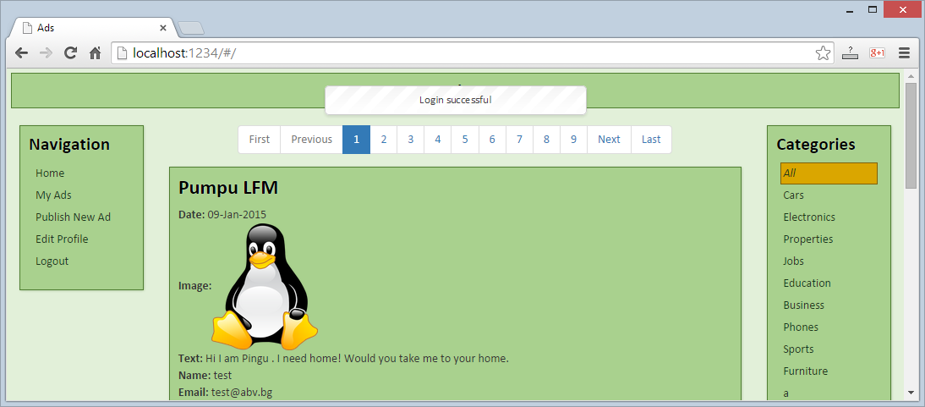

* + Check also the **incorrect login** functionality:

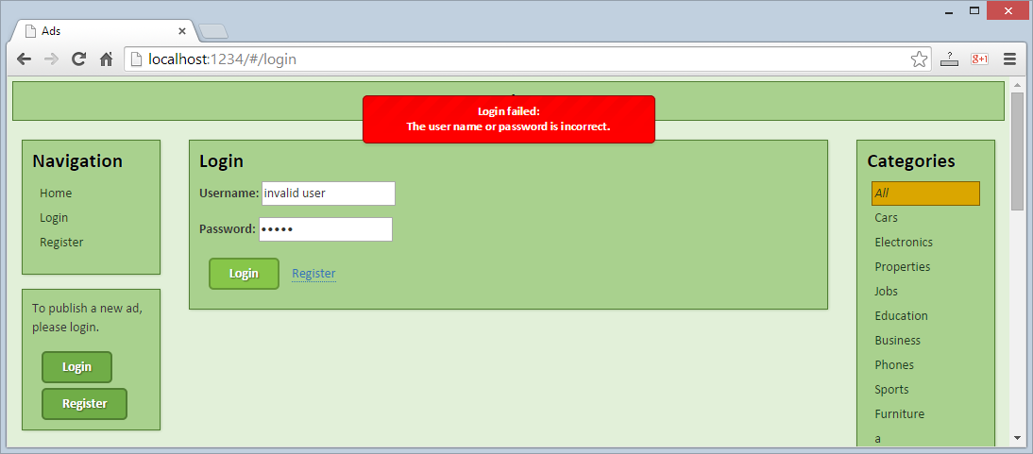

* + Check also the **logout** functionality:

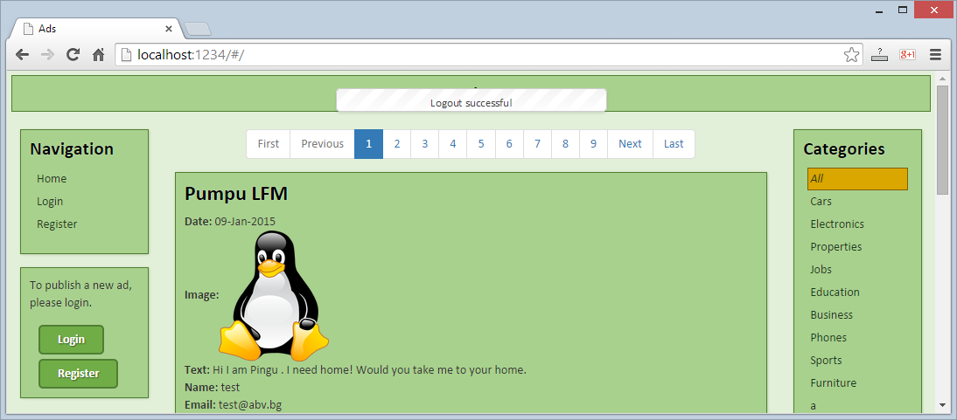

* + Check for errors at the Web browser's development console:

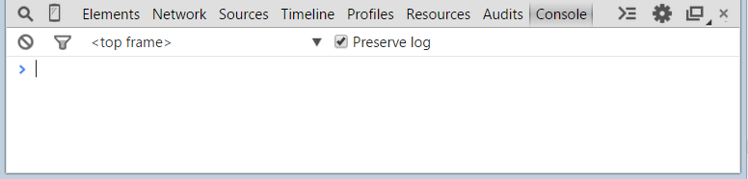

10 score

1. Implement the **site header**. It should display different content for anonymous and logged in users:

|  |
| --- |
| **header.html** |
| Ads<**span ng-if="pageTitle"**> **&ndash;** {{**pageTitle**}}</**span**>  <**div ng-if="authService.isLoggedIn()" class="user-area"**>    <**span**>{{authService.getCurrentUser().username}}</**span**>    <**a ng-click="logout()" class="link"**>Logout</**a**>  </**div**> |

Test the site header:

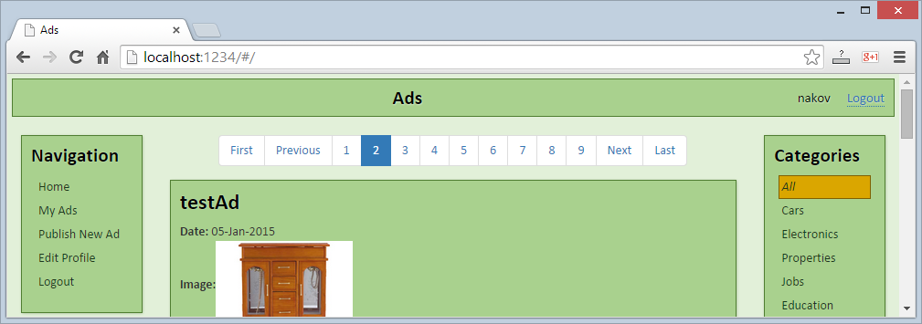

10 score